1. Objective of the Project

- To identify and develop suitable methods of producing fire retardant jute based fabrics either by blending jute with fire retardant fibres and/or by imparting suitable fire retardant chemical finishes.

- To optimize and standardize the suitable chemical formulations and application process for non-durable and durable (wash-fast) flame retardant finish of jute based fabrics.

- To study the flame retardancy and other thermal characteristics of blended or chemically finished fire-retardant jute fabrics, for assessment of end use performance as per existing National & International standards.

- To analyse the techno-economic cost viability for the newer routes /methods that will be emerged out from this project for developing fire retardant jute fabrics ( either by suitably blending with fire retardant fibres or by imparting fire retardant chemical finishes with appropriate formulations for imparting semi-durable and durable fire retardant property to jute-based fabrics) .

- To train manpower (students, industry personnel, consultants and researchers) in this field.

- Demonstration, Bulk trial and technology transfer to the Industry to develop usable products from such fire-retardant jute based fabrics and their required testing and standardization.

2. One Page summary report on Literature Survey

There are several non-durable flame retardant formulations for cellulosic’s ¹⁻⁴ such as –Borax, Di-Ammonium Phosphate, Borax:Boric acid(7:3) mixture, , phosphoric acid etc. which if applied in conjunction with resin finish, the non-durable flame retardant is mechanically entrapped into the textile matrix of the fabric and thus, becomes somewhat semi-durable. Also the use of such phosphate compounds with melamine-formaldehyde resin has been found to be another alternative method for fire proofing jute goods as semidurable FR finish of jute as studied in BJRI, Dhaka.⁵Among several durable flame retardants, available for cellulosics, the important ones are Antiminy oxychloride/Antiminy oxide. Tetrakis hydroxyl methyl phosphonium chloride (THPC)⁶, Tris-1-aziridinyl phosphine oxide (APO), APO-THPC combination APO-Zn (BFn)₂ or THPC-Thiourea or APO-Thio-urea combinations, THPC-antimony oxide combination etc. But none of these are ecofriendly for chances of problem of formaldehyde release in today’s context.
The toxicological hazards of conventional and commercially available THPC based flame retardants are often questioned in terms of the toxicity of the basic FR-retardant chemicals and also the hazards during the application and its end-use. These questions have been studied and reviewed by Mehta and Sharma⁷ for the commonly available such flame retardants for cellulosics. Whilst agents like tris(aziridinyl) phosphine oxide (APO) and antimony (III) oxide are also proved to be extremely toxic. In a concurrent paper by Macgregor et al. ⁸ investigate the potential mutagenicity of a no. of common flame retardants for cotton. Of all the phosphorus-containing flame retardants, including phosphonium, phosphine, phosphine oxide and phosphonate derivatives, all were found to be non-mutagenic. However, toxicity of two of the three bromo-alkyl substituted triazines (APO etc.) were investigated and it did exhibit mutagenic activity. THPC based flame retardants are though proved to be much efficient flame retardant agent, but this is not free from formaldehyde toxicity and hence, is not eco-friendly. Hence this interest of researcher, have been revised/renewed recently to find eco-friendly flame-retardant for cellulosics. For protection of consumers from unsafe fire hazard flame retardancy finishing of jute furnishing is considered to be high important especially for Floor coverings, upholstery and draperies, So, it may be said that for ligno-cellulosic fibres like jute, the work done so far on flame retardancy finish of jute fabric are mainly temporary ^{4, 5} types and that too is only limited in number as fire retardant chemicals.

3. Detailed report on literature survey with reference

A Detailed Literature Review based on different publications of national and international journals on related subject has been done and the hard copy and soft copy of the same is already submitted to NJB .

4. Need Assessment / Market Survey Report

Survey and Need Assessment were made by Questionnaire to Different Jute Mills and their responses besides expert opinion. The followings were the important outcome:

Only 19% of the DJP units have been producing fire-retardant jute fabrics for export market and carrying out ‘Vertical flammability test’ only.

Major amount of these treated fabric find use as ‘brattice cloth’ in coal mines and to some extent, it is employed as underlay fabric in furniture industry. Currently, market for fire- retardant jute goods is small which may be attributed to its leach-able characteristics, but application opportunities in home textiles (including pandel décor) can be expanded if non-leachable fire retardant finishing technology for jute is successfully developed.

81% of the DJP units appear to have either no infrastructure facility for production or no expertise/ know-how for the fire retardant technology.

45% of the DJP units seek earnest training needs for workshop/seminar, training of technician, and bulk scale demonstration on fire retardant finishes.

A Detailed Need Survey Report is already submitted.

5. Methodology of R & D Part of the Project

Application Procedure

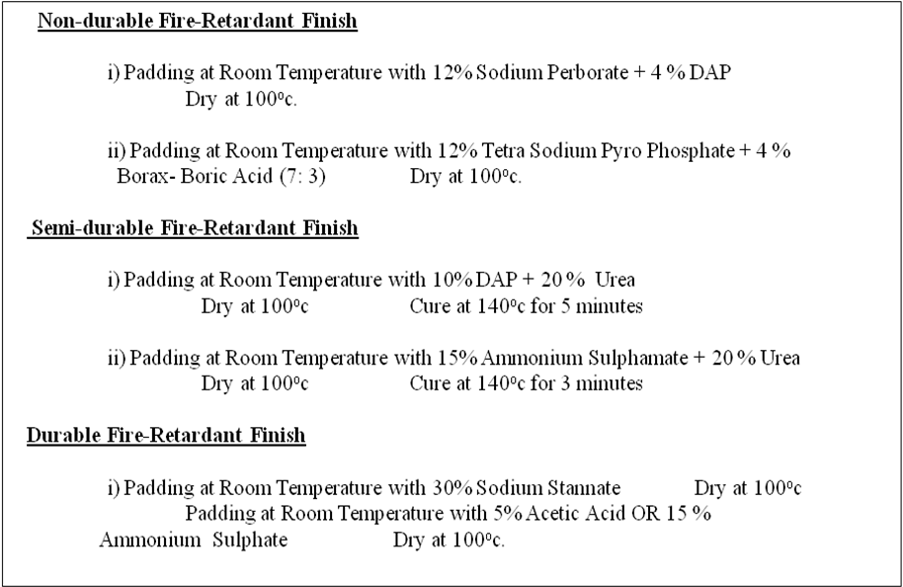

Evaluation Procedure

Measurement of Bending Length and Flexural Rigidity and Bending Modulus
The bending length of the selected fabric samples in both warp and weft directions was measured as per IS-6490-1971 method using Cantilever type Sasmira fabric stiffness tester with a specimen size of 200 mm × 25 mm. From bending length data, flexural rigidity and the bending modulus were calculated using the following relationships.
Flexural Rigidity of the Fabric in the Warp Direction (G₁) = MC₁³ X 10³ mg.cm
Flexural Rigidity of the Fabric in the Weft Direction (G₂) = MC₂³ X 10³ mg.cm
√ G₁ × G₂
Overall Flexural Rigidity (F) of the Fabric = mg.cm
Where, M= fabric weight (g/cm²), C₁ = bending length (cm) in warp direction, C₂ = bending length (cm) in weft direction.
Measurement of Breaking Tenacity and Breaking Extension
Warp-way breaking tenacity (cN/tex) and the breaking extension (%) of selected fabric samples were measured by the ravelled strip method as per IS-1969-1968 method using an Instron (Model-1445) CRT-Universal tensile tester with a traverse speed of 100 mm/min and a pretension of 0.5 N.
Measurement of Surface Colour Strength (K/S Values)
Surface colour strength in terms of K/S value was determined by measuring reflectance value of the textile substrate using a computer aided Macbeth 2020-plus reflectance spectrophotometer under D₆₅ standard illuminant and 10º standard observer setting using the following relationship(Kubelka Munk-Function) .
K/S =
Co-efficient of absorption
Co-efficient of scattering
=
(1 - R_{λmax} )²
2 R_{λmax}

Where K= the co-efficient of absorption, S = the co-efficient of scattering, C_{d} = the concentration of dye, R_{λmax} = the surface reflectance value at maximum absorbance wave length (λmax) .
Measurement of Whiteness, yellowness and Brightness Indices
Whiteness index as per Hunter Lab-Scale formula, yellowness index as per ASTM-E-313 formulla and brightness index as per ISO-2470-1977 formula of the selected jute fabric samples were directly evaluated using a computer aided Macbeth 2020 plus reflectance spectrophotometer (with D₆₅ standard illuminant and 10º standard observer setting) and associated colour measurement software,using following relationship.
Whiteness Index (Hunter Lab-Scale) = L − 3b = 10√Y − [21(Y−Z %)] / √Y
0.847Z
1 −

Yellowness Index (ASTM-E313/1973) = 100 (1−B/G) = 100
Y
Brightness Index (ISO-2470-1977)
Reflectance value of the substrate at 457nm × 100
=
Reflectance value of the standard white
diffuser/ white tile at 457nm

where, X, Y and Z are the tristimulus values of the sample, L is the lightness/darkness indicator in CIE Lab-Scale [L* or simply L = 16 (Y/Y_{o})^{1/3} - 16 as per CIE Lab-1976 formula], b is the blueness/yellowness indicator in the CIE Lab-Scale¹⁶{b* or simply b = 200 [ (Y/Y_{o})^{1/3} – (Z/Z_{o})^{1/3}]}, B = Z/1.181 = 0.847 Z, G = Y= L²/100 and X_{o}, Y_{o} and Z_{o} are the CIE-tristimulus values for D65 standard illuminant and 10º standard observer.

Testing of Flammability Performances
Selected untreated and treated jute fabric samples of specified length(15cmlegth and 5cm wide) was exposed to a standard flame for a specified time (for cotton it is 1sec, for jute it is 10 sec, standardized in this laboratory) and was allowed to burn in an inclined plane (45⁰ inclined ) Standard flammability tester(Make: Paramount, India,) following ASTM-D-1230-94 standard method. The fabric samples was mounted at 45 ⁰ angle in a specimen holder and was then exposed to a standard flame of specified height exposed at 90 ⁰ with the specimen for 10 second and is left for burning, to note flame spread time, afterglow time, and char length (in cm) after the burning. The time taken (t in seconds) for the flame to travel 12.5cm of the fabric sample mounted in the frame at 45 ⁰ angle for the fabric of specified length and width to burn was recorded on digital timer provided in the instrument. After glow time was measured with a stop watch and char length was physically measured by a scale.

Determination of Limiting Oxygen Index
Limiting Oxygen Index (LOI) are critical oxygen index values indicating the relative measure of flammability of any materials or textiles. If LOI values are above certain critical limit (say 27), there is hardly any chance of fire propagation. LOI testing instrument thus provides a precise method for determining the critical oxygen index of the sample by measuring the minimum volume concentration of oxygen gas in a flowing stream of mixture of oxygen and nitrogen gases (mixed in different volume ratio) required to maintain candle like burning of a sample for a specified time.
LOI values of selected untreated and treated fabric samples were determined in an standard LOI tester (Make: S C Dey & Co., Kolkata) as per ASTM-D-2863-77 method by using the following formula.

100 x Volume concentration of O₂
Limiting Oxygen Index (n) =
Volume concentration of N₂ + Volume concentration of O₂

6. Detailed Report on R & D
Following are the different fire-retardant formulation that have been tried
- Borax-boric acid
- Urea and Ortho-Phosphoric Acid,
- Tetra sodium Pyrophosphate,
- Sodium Per-borate etc.
- Following are some improved fire retardant formulations using Nitrogen and Phosphorous Compounds in combination (to get N-P Synergy), using Urea plus Di ammonium Phosphate (DAP), Thio-urea plus DAP and Dicyandiamide plus DAP
- For development of some eco-friendly fire-retardant treatment, i R&D trial have been done with Phosphorylation of polyols (PVA/PEG etc) and their subsequent application on jute fabric.
- Another one new improved fire retardant formulations using Nitrogen-Sulfur based fire retardants in combination (to get N-S Synergy), using Ammonium sulfamate/ sulfamic acid with urea or other nitrogen compound has been done
A detailed report on R & D studies is given herewith.

7. Results and outcomes of R & D activities
ITEM | QUALITATIVE | QUANTATIVE | ACHIEVEMENTS
Deliverables for Project-10 | 1 (a) Standardization and Development of Non-durable and Semi-durable fire retardant recipe as compared to commercially available fire retardant compounds on jute. | At least two such formulations for non durable and semi-durable fire retardant finish on jute. | 4 formulations (2 non-durable and 2 semi-durable) of fire retardant finish on jute have been developed by IJT; detailed report is submitted already.
Deliverables for Project-10 | 2 (a) Development of Durable Fire-retardant formulation and further improvement of Semi-durable formulations of fire retardant finish on jute.  (b) Test Results of different formulations applied on jute fabrics. | At least two such formulations on jute for durable formulations of fire retardant finish on jute, To achieve:  LOI value--40-45 (approx);  Char-length (cm)-- 1-2.0 cm;  Flame spread time-- maximum flame spread time be 100 seconds for burning 2 cm ;  Burning time-- Burning of 1-2om should take at least 60 sec .or more;  Afterglow time-- Preferably no afterglow or below 5 seconds. | -One durable fire retardant finish formulation on jute is standardized and LOI achieved is 38 without wash and 35 after wash.  - -SITRA has developed some recipe  -Test results of the formulation developed so far, has been cited in the technical report of 2nd year.
Manpower Training | Training and Demonstration of the newer developed processes of fire-retardant finishing on jute. | At least 10-15 industry personnel covering interested mills/unit. | Yet to be done, after the last installment of fund is received.
Field trial and cost analysis | Bulk trial on jute fabric for developed FR finish. | In one or two units | Two field Trials are done in Reliance jute Mill and Gloster Jute Mill.  Cost analysis is already done and submitted to NJB

The Major Thermal and Tensile Properties of the FR-treated jute fabrics

Formulation | Loss in Tensile Strength (%) | LOI (%) | Char length (cm) (Vertical Flammability test)
Untreated Bleached Jute Fabric | Nil | 20.5 | BEL
A ) Non-Durable
1. Perborate based FR Recipe | 10.7 | 28.5 | 7.5
2. Pyrophosphate based FR Recipe | 10.4 | 28 | 9
B) Semi-Durable
3. Ammonium Sulfamate Based FR Recipe | 25.5 | 38 | 2
4. Ammonium Phosphate Based FR Recipe | 28.7 | 37.5 | 2
C) Durable
5. Stannate Based FR Recipe | 16.5 | 34 | 5

Dissimination Seminar / Work Shop

The objective of the workshop is to disseminate the midterm results/ findings of the project among the jute mills, DJP manufacturers /exporters and entrepreneurs, to interact with industry’s representatives and to raise their valuable opinions / views for delivering useful project outputs to both organised and decentralised jute sectors.
The workshop was attended by about 75 delegates including representatives of JMDC, NCJD, IJMA, AJHEEI, individual jute mills, diversified jute product manufacturers / exporters and scientists/ technologists of TRAs and IIT, Kharagpur [ Total list of participants is given at the end of the proceedings ].
The workshop was organised as per following schedule:
- Inaugural session
- Presentation of the project report/ paper followed by interactions with the jute mills’ representatives, DJP manufacturers/ entrepreneurs and PMEC
- Display of diversified jute products produced during the project period

A detailed Seminar Proceeding is given earlier.

Final Dissemination Work Shop:
Final Dissemination Workshop of JTM R & D Projects of DJFT, IJT, CU was held on 27th June 2012 at “KENNEDY HALL”, DJFT, IJT, CU. The objective of the workshop was to disseminate the final outcomes / findings of the four JTM-R & D projects among the large scale and small scale jute sector as user industry including jute mills, JDP manufacturers /exporters and entrepreneurs as well as scientists and researchers of jute sector by direct interaction with them in this Final Dissemination workshop to receive their feedback and valuable opinions / views for effective utilisation / commercialization of the outcome and possible way forward about the outcome of these JTM-R&D projects in both organised and decentralised jute sectors and relevant users. The workshop was attended by about 90 delegates including representatives of IJMA, NJB, AJHEEI/JDPEPC, individual jute mills, individual jute diversified product manufacturers / exporters and scientists/ technologists of Jute Research Institutes

A detailed Seminar Proceeding of Final Dissemination Workshop is submitted earlier to NJB and is however further enclosed herewith.

8. Product Process Standardization

Process Developed under the JTM R&D Project No. 10

Standardized Recipe and Process Conditions of Two non-durable and two semi-durable and one durable fire retardant finishing on jute.

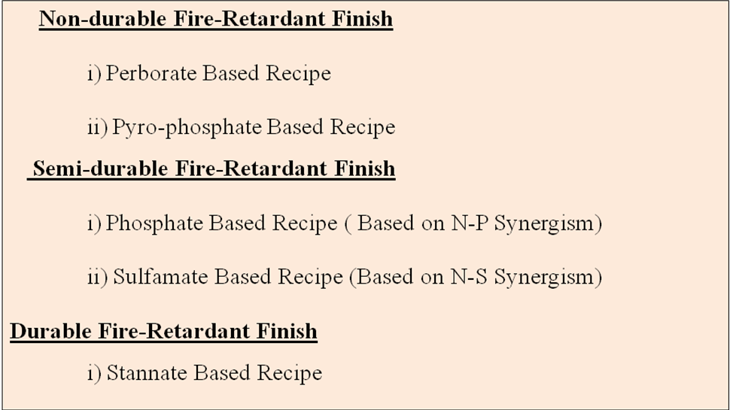

The Detailed of the Standardisation process are explained in the detailed R&D Report is submitted herewith.

9. Report on Pilot Scale and Bulk Scale Trials

The 1st bulk Scale Trial Report
As per terms of reference of the above referred Project No.-10, the following work for bulk trial to produce fire-retardant finished jute fabric with selected FR-formulation is an industrial process have been carried out:

Venue: Reliance Jute Mills (International) Ltd., 80, West Ghoshpara Road P.O. Bhatpara, 24 Pgs. (North), Near Kankinara Railway Station was identified for bulk scale trials / lives demonstration on Fire-retardant finishing on jute based textiles.

- A bulk scale trial was arranged on 28th and 29th May 2011 in order to evaluate/ try out the laboratory recipes / findings in actual mill conditions and subsequently to rectify / optimise for achieving the targeted Finish.

- To carry out the above mentioned experimentation in bulk scale, the required Chemicals of commercial origin were purchased from the local market and dissolved in water to obtain the developed standardized recipe for the required recipe.

- Jute fabric rolls of 200 metre length (290gsm; 14 x15 threads/inch) were used for fire-retardant finishing of jute fabric. Chemicals used were Ammonium Sulfamate, Urea, Sodium Stannate, Acetic Acid, Sodium Perborate.

- Test results are encouraging and given at end of this report.

- The workshop / live demonstration of fire-retardancy of jute fabric were attended by 30 number participants represented from jute mills, DJP units, dignitaries / officials of NJB and JCI. The most interesting part of the session was one to one interaction and live discussion.

Test Results of the Bulk Trial Samples

Treatments | Vertical Flammability Test (IS: 11871-1986) |  |  | LOI %
Treatments | Char length (cm) | Flame Spread Time (Sec) | After Glow (Sec) | LOI %
Untreated Bleached Jute Fabric | Burned Entire Length |  |  | 20.5
Perborate treated Bleached Jute Fabric | 7.5 | 7 | 12 | 28.5
Sulfamate treated Bleached Jute Fabric | 1 | nil | 6 | 38
Stannate treated Bleached Jute Fabric | 5 | nil | 25 | 34

The 2nd Bulk Scale Trial Report

As per terms of reference of the above referred Project No.-10, the following work for bulk trial to produce fire-retardant finished jute fabric with selected FR-formulation is an industrial process have been carried out:

Venue: Gloster Ltd. (Formerly Gloster Jute Mills Ltd.), Post: Fort Gloster, Bowreah, Howrah – 711310 was identified for bulk scale trials / lives demonstration on Fire-retardant finishing on jute based textiles.

- A bulk scale trial was arranged on 25th and 26th November 2011 in order to evaluate/ try out the laboratory recipes / findings in actual mill conditions and subsequently to rectify / optimise for achieving the targeted Finish.

- To carry out the above mentioned experimentation in bulk scale, the required Chemicals of commercial origin were purchased from the local market and dissolved in water to obtain the developed standardized recipe for the required recipe.

- Jute fabric rolls of 200 metre length (290gsm; 14 x15 threads/inch) were used for fire-retardant finishing of jute fabric. Chemicals used were Ammonium Sulfamate, Urea, Sodium Perborate.

- Test results are encouraging and given at end of this report.

- The workshop / live demonstration of fire-retardancy of jute fabric were attended by 28 number participants represented from DJP units, dignitaries / officials of NJB and JCI. The most interesting part of the session was one to one interaction and live discussion.

Test Results of the Bulk Trial Samples

Treatments | Vertical Flammability Test (IS: 11871-1986) |  |  | LOI %
Treatments | Char length (cm) | Flame Spread Time (Sec) | After Glow (Sec) | LOI %
Untreated Bleached Jute Fabric | Burned Entire Length |  |  | 20.5
Perborate treated Bleached Jute Fabric | 8.0 | 6 | 13 | 27.5
Sulfamate treated Bleached Jute Fabric | 1.5 | nil | 5 | 36.5

10. Cost Analysis / Cost Effectiveness study report

Final Cost Analysis based on bulk scale trial for Fire Retardant Finishing of Jute
(For Formulation 1- Perborate based)

Elements | Cost ( in Rs. / Linear meter)
Fire-Retardant Finishing Cost
i) Fire Retardant finishing Chemicals | 2.0-2.5
ii) Water and Effluent Treatment | 0.35-0.40
iii) Manpower | 0.45-0.50
iv) Steam | 0.34-0.40
v) Electricity | 0.25-0.30
Drying Cost in CDR
i) Manpower | 0.3-0.40
ii) Steam | 0.66-0.70
iii) Electricity | 0.42-0.50
Total Cost ( in Rs. / Linear meter) | 4.77-5.70

Final Cost Analysis based on bulk scale trial for Fire Retardant Finishing of Jute
(For Formulation 1- Sulfamate based)

Elements | Cost ( in Rs. / Linear meter)
Fire-Retardant Finishing Cost
i) Fire Retardant finishing Chemicals | 4.4-5.0
ii) Water and Effluent Treatment | 0.35-0.40
iii) Manpower | 0.45-0.50
iv) Steam | NIL
v) Electricity | 0.25-0.30
Drying Cost in CDR
i) Manpower | 0.3-0.40
ii) Steam | 0.66-0.70
iii) Electricity | 0.42-0.50
Curing Cost in Stenter
i) Manpower | 0.3-0.40
ii) Steam | 1.9-2.2
iii) Electricity | 0.80-1.0
Total Cost ( in Rs. / Linear meter) | 9.83-11.4

Assumptions:
- Fabric used : 51”-15X14; 280 GSM or ~ 336 gm/linear metre; 1kg = 3.00 metre
- Rate of the Above mentioned Fire-Retardant Chemicals (Commercial Grade)
i) Sodium Perborate Rs. 55/- per Kg
ii) Ammonium Sulfamate Rs. 70/- per Kg
iii) Urea Rs. 10/- per Kg
- Steam generated by coal.
- Electricity Rs. 5/- per unit.

11. Conclusion with recommendations-way forward

- One Non-Durable and One Semi–Durable Fire-retardant Recipe and Process Conditions were standardized on jute in the present industrial condition.
- 12% Perborate Based Recipe having 28.5 LOI and 7.5 Char Length was Standardized as One Non-Durable FR-formulation with simultaneous bleaching action.
- 15% Ammonium Sulfamate + 20% Urea Based Recipe having 38 LOI and 2 Char Length was Standardized as One Semi-Durable FR-formulation.
- Interested Jute Mills may implement those recipes.

12. Separate booklet for the use of the Industry.

Manual is already submitted to NJB

ADDENDUM

1. Standardization of Cost viable fire retardant Formulations

We have send a draft to BIS for standardization of Fire –retardant formulations as BIS standards for Fire-retardant Jute fabric (Semi-durable and Durable) to be placed in Tx-03 or in appropriate BIS committee for inclusion as a new standard, as there is no separate standard established so far for fire-retardant jute fabric (Copy of the letter attached).

2. Effort for Commercialization

For commercialization of the indigenous fire retardant formulations developed by IJT under JTM R&D project we have a meeting with The Global Head Mr. Anjani Prasad of Clariant and eastern Regional representative Mr. Ashim Ghosh on 26.12.12 for Non-disclouser cum Licensing Agreement on the same (Mail enclosed) for easy and commercial availability through Clariant for the benefit of the industry. We are now working with them to make our formulations commercially available to industry easily from market for application on jute and other cellulosic.

